# DECLARATION

We, the undersigned, declare that this Project that name as walya bus reservation and management systems is our original work and all sources of materials used for the Project have been fully cited.

Name Signature

1.Asrar Mohammed __________

2.Henok Tilahun __________

3.Woldieabraha Atsbeha __________

This Project has been submitted for examination with my approval as a university advisor.

_____________________ _________

Project Advisor Signature

This semester project has been submitted for examination with our approval as a University advisor and examiners.

1. __________________ _________________

2. __________________ _________________

3. _________________ __________________

# ACKNOWLEDGMENT

First, we are grateful to the Almighty God for enabling us to complete this final project work. It is our pleasure to thank our advisor Mr Halid.A for being there in guiding and appreciating our work. We are thankful for their aspiring guidance, invaluably constructive criticism and friendly advice during the project work. We are sincerely grateful to them for sharing their truthful and illuminating views on a number of issues related to the project. Finally, we take this opportunity to sincerely thank all the department members of Electrical and Computer Engineering (computer focus) for their help and encouragement in our educational endeavors.

Table of Contents

DECLARATION i

ACKNOWLEDGMENT ii

List of figures v

List of tables vi

ACRONYMS vii

ABSTRACT viii

CHAPTER ONE 1

INTRODUCTION 1

1.1 Background of organization 1

1.2 Statement of the problem 2

1.3. Objective of the project 3

1.4. Scope of the project 3

1.5. Limitation of the project 4

1.6. Significance of the project 5

1.7 Methodology 6

1.8 System Development Tools 6

CHAPTER TWO 7

LITRATURE REVIEW 7

CHAPTER THREE 9

SYSTEM DESIGN AND DEVELOPMNET 9

3.1 Requirement analysis 9

3.1.1 Functional requirement 9

3.1.2 Nonfunctional requirement 9

3.2 Feasibility study 10

3.3 Existing system description 11

3.4 The Proposed system 12

3.5 Input and output of the proposed system 13

3.6. System use case Identification 14

3.7 Use Case Descriptions 18

3.8 User Interface prototype 28

3.9 activity diagram 29

3.10 Sequence diagram 34

3.11 System design 38

3.11.1 Deployment diagram 38

3.11.2 Architecture of the proposed system 39

3.11.3 Persistence modeling 41

3.12 Class diagram analysis 42

CHAPTER FOUR 43

RESULT AND DISCUSSION 43

CHAPTER FIVE 48

CONCLUSION AND RECOMMENDATION 48

5.1 Conclusion 48

5.2 Recommendations 48

6.3 Constraints 49

REFERENCES 50

APPENDEXIES 51

## List of figures

Figure 3. 1work flow of proposed system diagram 18

Figure 3. 2 use case diagram 21

figure 3. 3 User Interface prototype 32

figure 3. 4 activity diagram for login 33

Figure 3. 5 add schedule activity diagram 34

figure 3. 6 activity diagram for reserve ticket 35

figure 3. 7 activity diagram for cancel ticket 36

Figure 3. 8 sequence diagram for create account 38

Figure 3. 9 sequence diagram for delete account 39

figure 3. 10 sequence diagram for reserve ticket 40

figure 3. 11 Sequence diagram for add bus schedule 41

figure 3. 12 deployment diagram 43

Figure 3. 13 Architecture of the proposed system 44

figure 3. 14 Persistence diagram 45

figure 4. 1 User interface for create login form……………………………………………. ……50

figure 4. 2 Figure User interface for view schedule 51

figure 4. 3 User interface for ticket reserving form 52

figure 4. 4 User interface login page 53

## List of tables

table 3. 1 List of Actors and Use Cases Associated with the new system 22

table 3. 2 Use case description for login use case 25

Table 3. 3 Use case description for reserve ticket 26

Table 3. 4 use case description for cancel ticket 27

Table 3. 5 Use case description for view schedule 28

Table 3. 6 Use case description for view reservation 29

Table 3. 7 Use case description for add route 30

Table 3. 8 use case description Create account for ticket officer 30

Table 3. 9 Use case descriptions for add schedule 32

Table 3. 10 Use case description for add bus 33

# ACRONYMS

AC Alternative Course

CSS cascaded style sheet

GB Giga Byte

GUI Graphical User Interface

HTML Hypertext Mark-up Language

MBTS Mobile Bus Ticketing System

OOSD Object Oriented System Development

PHP hypertext pre processor

PLC programing logic control

RAM Random Access Memory

SST Self Service Technology

UC Use Case

UML Unified Modeling Language

WAP Wireless Application Protocol

# ABSTRACT

The project, which is the aim to build, is Walya bus ticket reservation and management system. Which is a web based application that allows the customer to check availability of tickets reserve a seat in this project, we designs. It is a simple system device. Users can install this system device in the bus and use it without any difficulty.

The project focuses on developing a web based online ticket reservation and management system for walya bus transport Share Company. In this paper, we try to describe how manual system will be change to the new computerized system, which is online application that allows customer to check availability of ticket online at any time at any place and enable their customer to reserve a seat online without going to the office physically. After the finishing of this project the company will get many advantages such as it will provide a good service to their customer this will lead the company to be profitable and it makes the data handling of the company organized.

The project describes a web based prototype solution implemented in PHP as a programming tool and MYSQL database as the back end to store data. The report presents the project’s lifecycle including the requirements analysis stage, design using UML modeling followed by the implementation phase and lastly testing the final product. We hope the proposed system will bring a great change on the way the current system operates. Finally, we have done from the proposal and we have implemented the system what we have proposed to implement.

# CHAPTER ONE

# INTRODUCTION

As there are many problems face human being throughout their life, it is obvious to solve many of the problems using digital technology. When saying this as the computer is the modern technology problem solver, anyone can solve his/her problem by developing the software that make its work computerized. So we have prepared a project as a precondition for solving many of the problems of walya bus ticket System that is implemented manually. Therefore, this work that manually performed needs to be automated to reduce the problem happened. The Online Bus Ticket Reservation System is online application that allows visitors to check bus ticket availability, and register for bus ticket online. This system is established for all the home/office users after gaining access from the administrator. Online Bus Ticket Reservation system provides bus transportation system, a facility to reserved seats, cancellation of seats and different types of enquiry, which need an immediate and quick reservation. The users in performing online reservation via internet for their all business purposes can use this system. Users can use this program directly on their websites and no need to install it [1].

Bus Ticket Reservation System enables the customer to register for bus ticket, and ask for information online easily. Furthermore, staff can sell bus ticket using Bus Ticket Reservation System after check bus ticket availability for the customer and print the bus ticket to the customer that queue up in the counter.

## 1.1 Background of organization

Walya bus Transport Share Company was established in Addis Ababa as (walya bus transport plc). The aim of Walya Bus Transport Company is “to render reliable, safest, comfortable & modern public transport service in Ethiopia”. To this effect and in order to raise a capital that would enable it realize its mission and vision as well as have more service coverage, Walya Bus is committed to maintain the ease and convenience as well as the comfort of its passengers by regularly making arrangements of efficient and standard reception services on their behalf and furthermore the aim is to raise its capital so as to give efficient and modern bus service by importing very modern buses possessing the state of the art technology including internal café and toilet services, all to the satisfaction of its clients. Walya Bus Transport Share Company established to alleviate the prevailing nation-wide shortage of public transportation, the transportation offices are Addis Ababa under st stephanos church, Bahirdar papus hotel, Gondar office crosser (piassa), Woldia office chairman under the building, Mekelle office under menel hotel, currently walya bus routes from Addis Ababa to Mekelle, Gondar, Woldia Bahirdar and Hawassa cities. [4]

## 1.2 Statement of the problem

Walya bus Transport System Company uses manual system, which requires a lot of resource like, manpower, stationary materials and so forth. And also, the system is slow and inaccessible to their customer. From the point of view of customer, the current system is very wasteful which require a lot of time and money. For example, if a person wants to reserve a place in the bus he/she must go to the office his/her time and money are lost

System that are using by the staff at the counter currently is an internal system and just used to sell the bus ticket at the counter. Customer has to go to the counter to buy bus ticket or ask for bus schedule. Furthermore, customers need to pay cash when they buy the bus ticket and sometimes needs to queue up long time to get the bus ticket. Besides that, customer also not allowed to buy bus ticket through telephone and the bus Company’s telephone always busy line.

Due to this reason the current system is faced the following problems. Such as:

* Preparation of unlimited ticket paper.
* It does not well-organized and updated working ticket process.
* There is some ticket cheating which some passengers may do it.
* Unwanted amount of resource is missing with improper usage.
* Customers might make errors in filling the information on the ticket form paper means that when the customer tells unwanted personal information to the ticket officer.
* The customer may be tied up with extra work to buy ticket
* The ticket buying time may be finished when customers does not reach the office in case of transportation
* Their client who is responsible person to give ticket might not be present by that time.
* Employees might be made complaint with some passengers.
* It may lacks security means that any unauthorized person might see the customer’s data the data is handled by manually.

We designed this project, which intends to give a solution that can be implemented and effectively used in developing countries like Ethiopia. The system we developed uses a reliable and modern technology, which is at the same time very cheap to implement, it also will modernize the way in which material management in museums and other related places has been approached. It will also solve the problems that will arise from dependency on the efficiency of the manual system. The proposed management system is designed to monitor and manage buses that are used by individual parties for a particular purpose, to slow and disable the bus in the event of theft and to track it online for retrieval. This system is the integration of several modern and integrated communication technologies.

## 1.3. Objective of the project

**General objectives**:

The general objective of the project is to develop online bus ticket reservation system that will replace the manual ticketing system.

**Specific Objectives:**

In addition to general objective, the project will also contains the following specific

Objectives: -

* To enable the user to interact or introduce with the new technology.
* Provide a system that reduces the manual work.
* To enable customer to check the availability of the ticket.
* To enable customers confidentially to reserve ticket
* Design the new system that can overcome the problem of the current system.
* To enable customer to check the availability of the ticket.
* To enable customer to check the time departure and arrival for every bus thought the system.
* To provide anytime service if the connection is available, customer can reserve a seat 24 hour a day and 7 days a week over the internet.

## 1.4. Scope of the project

The project is focused on developing of interactive online walya bus ticket reservation system all branch. Our proposed system includes online ticket reservation system, show schedule, show availability of ticket, cancellation of ticket, view comment to user, print ticket and reports, add and update schedule, add and delete bus information, add and delete route service and generate report. Some of our proposed system performs the following functions with description.

* **Make reservation**: -the system supports make reservation for passengers.
* **Show schedule: -**the proposed system of the project is support the passengers to see schedule of tickets in the system.
* **Show availability of ticket**: -the proposed system of the project is support the passengers to see availability of tickets in the system.
* **Show availability of seat**: -the system shows availability of seat numbers of the passengers so the passenger see his/her own seat numbers based on the system required personal information from users.
* **Cancellation of reservation ticket**: -the proposed system also cancels.
* **Generate report**: - the system supports the managers to generate reports that are related to passengers and actors of the data.
* **Add bus: -**the system supports to add bus for the reservation.
* **Update schedule:** the system includes postponing reservation for the next and the day that any case related to the company and the users.
* **Search, insert, delete, and view traveler’s data: -**from the system database the authorized user can view data has, delete, and insert appropriate information.
* **Update account; -**the system also supports to update accounts of user by authorized actor.

## 1.5. Limitation of the project

At the end of this project the new functionality in each module will be able to solve many of the problems in the existing system. But, even the proposed system will not perform online payment because, it needs linking with the banking system no language choice i.e. only in English reader and write use the system, email subscription and the system will not allow the organization to communicate with other private transport organization. The proposed system is not going to perform or what is not including in the proposed system are -

* The system is available for only one type of bus i.e. only walya bus.
* Illiterate person cannot access the system.
* The system can’t operate Maintenance system.
* Serving passenger out of the concerned destination.

## 1.6. Significance of the project

As mentioned in the previous section, the online system is new in Ethiopia. It is very important to company's customer, and Bus Company. It is important to customer because customer can check availability of the bus ticket, buy bus ticket, and pay the bus ticket online. Online ticketing system is different with traditional paper ticket because online ticketing system is safer, faster, reliable and cheaper. Besides that, this concept can be used by others bus company so that their customers will be easier. The profit for the bus company will be increased because the online system will attract more customers and no need to hire many staffs at the counter to sell bus ticket because ticket can be sold efficiency online. The project is very important to the organization and company’s customer.

For the company:

* + - * + It increases their profit by making their expenditure less.
        + It increases customer satisfactions.
        + It reduces the required man power.
        + It helps the company to handle customer information in an organized way.

For company’s employee

* + - * + Reduced workload, they are only responsible to feed data to the system.

➢ The system performs the difficult and the time consuming task for them.

For the customer

* + - * + It reduces the wastage of time and money.
        + It reduces the exertion of customers during reservation.

For developers

* + - * + To develop the skill and knowledge to develop an industrial project.
        + Learn to do things in a group which is more advisable.
        + Enables us how to respond to problems and design new improvement.
        + We can also have experience in developing systems.

## 1.7 Methodology

Data collection methodology, the method of Requirement gathering that is used on this project includes Interview, questioner, Observation and document analysis to collect/ gather information and data of the existing system to develop new system.

**Interview**: - we contact the representative of the organization using phone calling and then exchange some ideas about their current system, how it has been working and the structure of this organization, and also phone interview call to admin to gather some information’s that do not accessed from ticket officer. As a general, we gather enough data in order to prepare our project.

**Observation:** we will look and examine how the workers are doing their work so that I could understand the existing system. We will observe the actual work in scheduling staff of the organization to gather additional data (i.e. manual class scheduling system) being done by the organization and consolidated with what was obtained through observation.

**Questioner:** - by preparing question papers we will try to get necessary information about the organization and helps us to do the system in a good way.

**Document analysis**: reading the document available in the organization and by visiting the organization.

## 1.8 System Development Tools

For designing our system, we select good developing environment and programming tools based on the knowledge and experience we have depending on the new technology**.**

**Software tools**

* Text editors i.e. sublime text
* Wampp Server
* MySQL 5.6.12 for developing database of the system.
* Programming Language Like HTML, CSS, PHP

**Hardware tools**

* Laptop computer
* Data cables
* Desktop computer

**Documentation tools**

* MS office 2016 and MS word 2013
* Visio 2016, draw.io

# CHAPTER TWO

# LITRATURE REVIEW

Throughout the development of our project, we were able to review some projects, journals, articles and books, which are related to the title of our project. We believe that all the reviewed materials have been a good asset for the overall design and development of the project we have chosen. In this section, some of the related projects we have reviewed are discussed.

**Mobile Ticketing (M-Ticketing)**

The Mobile application grouping accessible in the tourism industry as mentioned, there are four main mobile travel application categories “Online Booking”, Information Resource”, “Location Based Services”, and “Trip Journals”. The “Online Bookings” category (Smirnov, Kashevnik, Shilov, Teslya, & Shabaev, 2014). These applications allow a tourist to make online reservations for different services (e.g., Bus travel, car rental, hotel, airplane ticket booking).

Mobile ticketing (m-ticketing) can be broadly defined as ordering, purchasing, delivery and usage of a product or service using mobile technology such as Wireless Application Protocol (WAP) (Skarica, Belani, & Illes, 2009). The mobile ticketing industry is a relatively recent and up-and-coming portion of the fast-growing e-commerce industry. The mobile ticketing predictions are being the research domain for several years. M-ticketing permits a customer to purchase a valid and legitimate ticket through mobile phone application. The value added services provided by the application allows users of the mobile ticket to store digital tickets on the phone. By doing so, the consumer is less likely to lose his ticket, eco-friendly, durable, cost effective and paperless. Generally, the mobile ticketing process can be defined in the following steps.

* Registration: Online ticketing requires a company to register with all the business and services information.
* Provisioning: Allow mobile phone application to interact with customers, allowing the purchase to take place.
* Validation: Validating and legitimate the ticket via electronic validation system between the company and the customer.
* Ticket check: Controller to verify and accept the sales and display of the mobile ticket as a valid ticket for the passenger, according to the terms displayed on the ticket.

**The “hello taxi services”**

Is a free software application from the vertical market apps subcategory, the app is currently available in English language and the program is installed on android, The passenger can engage the taxi from anywhere at any time. They can login to their account by providing the details mobile number and password. and also the passenger can manage their profile, they can also view the details of current trip, trip history, and trip plans. the passenger has to provide the pickup and drop location and other details to book the taxi. taxi fare is calculated based on distance automatically. Payments can be flexibly done by via cash or card. Some of the features of hello taxi customer app includes:

* Register/login
* Profile management
* Current trip
* Trip history
* Locate taxi on map
* Book taxi or cancel trip
* Booking details
* Waiting time
* Payment option(card/cash)
* Rate the driver
* Taxi fare

Currently in our the hello country Ethiopia the ride technology is developed in Addis Ababa, this technology services is much approach features with hello taxi system and both are the model of our systems development.

# CHAPTER THREE

# SYSTEM DESIGN AND DEVELOPMNET

## 3.1 Requirement analysis

### 3.1.1 Functional requirement

Functional requirements are statement of services the system should provide, how the system should react to particular inputs and how the system should behave in particular situation. Below are the functional requirements of the system are listed:

* The system enables manager to add, update, routes and dates of bus entry to the system.
* The system allows passenger to register to the system.
* The system allows a registered user to reserve tickets online.
* The system allows the passenger to cancel the reserved ticket.
* The system allows checking the availability of bus in the required route easily.
* The system should store all information of the passenger and walya bus.
* The system allow user to see bus departure and arrival of walya bus.
* The new system should be able to detect input syntax errors such as input of characters where numbers are expected. The system should ignore the faults inputs and generate error message.

### 3**.1.2 Nonfunctional requirement**

Non-Functional requirements describe user visible aspects of the system that are not directly related with the functional behavior of the system. But it can support and give more quality for the new system. The system is effective and consistent in that integrity of information is maintained and supplied to the system. The ability of a system to perform its required functions under stated conditions for a specific period.

**Usability** The system should provide an easy-to-use graphical interface so user can easily learn how they use the system. The system should be user friendly so that users can use it easily without confusion. The web interface should be intuitive and easily navigable Users should be able to understand the menu and options provided by the system

**Security** To use the system a user must first register to system and log in to the system but if unregistered user try to reserve without having registering the system doesn’t allow the user to use the system. The authorization mechanism of the system will block the unwanted attempts to the server and also let the system decide on which privileges may the user have. The system has different types of users so there are different levels of authorization.

**Performance** is the ability of system to response quickly and optimal workload. Is how fast

(speed) of operation of a system. Which is mean: -

* The system does not take up too much space in memory to store system’s data.
* The system is very fast since it is automated.
* The software shall support use of multiple users at a time.
* It works very well with short response time, high throughput and high availability.
* Reduce costs and time waste by providing access to system in available place and time where Internet connection is available.

## 3.2 Feasibility study

Feasibility study is essential to evaluate the benefits of the new system. Based on the feasibility study decision is taken on whether to proceed or to cancel the project**.**

**Economic Feasibility**

The purpose of assessing economic feasibility is to identify the financial benefit and cost association with the proposed system, economic feasibility is referred to us cost benefit analysis. We are going to determine economic feasibility of this project by dividing into two.

Those are tangible and intangible benefits.

1. Tangible Benefits: -Benefits that are easily quantified from the conducted system are:
   * + - * Save time and make comfortable access for the users.
         * Reduce cost for manual data management (Reduced expenses).
         * Reduce Resource Consumption.
2. Intangible Benefits: -Benefits from the system that areas unquantifiable are;
   * + - * Better decision making
         * Enable efficient registration service to all users.
         * Increase security
         * Increase Management flexibility

**Operational feasibility**

The system can be used effectively after it has been developed. Users will not have any difficulty with the new system, producing the expected benefits. The System we will develop is very attractive for users and easy for use. Therefore, the system is operationally feasible.

**Technical feasibility**

Technical feasibility measures the practicality of a specific technical solution to the problem. It is also a measure of the availability of technical resources and expertise. Technical feasibility is assessing the organization’s ability to construct the system. The system can be technically feasible because the technical resources need to develop, install and to operate is available in the present infrastructure.

## 3.3 Existing system description

The existing system that has been practiced in walya bus organization is manual system and ticket reserving systems are monitored with paper work. Workers and passengers are move to the ticket office in directly going to the office room to another room in the organization, workers communicate manually. The major stakeholders of the current system are passenger, ticket officer, system admin and manager of the organization. The main role of passenger: - the role of passenger in the system is to become: reserve ticket, give comment to the organization, fill his /her own personal data, and know route information.

The main role of ticket officer: the role of ticket officer is the system is to become confirm reservation, deactivate the reserved ticket, view comment that already written by passengers, and also know the passenger’s data in the database.

**Ticket reservation** it is done by storing the details of the reserved ticket by a paper file and sometimes by simply a word document in the office computers. This act of ticket reservation is not reliable for future usage of the data; it may be lost by different reasons like computer hard disk failure, data corruption by malware and even by catastrophic damages.

**Ticket cancellation** in the organization is done like reservation means that to cancel the reserve ticket that already usable it is difficult because there is occurrence of redundant data, may be the document that handle the ticket is lost or damaged at that time the organization become loss and difficult to calculate amount of reserve ticket and cancel the ticket if the ticket document is lose or hide.

**Postpone reservation** in the existing system users don’t have known whether the reserve ticket is reserve or postpone .so in this time the organization is not option to address the ticket is postponing to the next day or the day after tomorrow to users, to inform the organization may use different materials like: magazine, newspapers, leaflet but this act of distribution information is not available in some area. All individual not access the posted information.

**Comment writing:** when the user went to give the comment they came to the organization and give their comment orally to the servants or write on a paper depend on customer issue. In case this is bother for the servants and the customer to work. Also the organization may be busy.

## 3.4. The Proposed System

By carefully analyzing and observing the problem of existing system we came up with a solution that the current manual system should be computerized. The computerized system will eliminate/reduce the problem on time, work load and complexity on storing passenger’s information and ticket related information. The system will include a database for recording tickets and the passenger’s data that facilitate fast information retrieval, modifying, inserting and deleting. It also includes an attractive user interface that facilitates accessing the database.

The system gives an id for those ticket reserve registered in the organization to reserve ticket. So that it is easy to work with all the processes in the organization. The user registers them so the system will give an id number to the passengers. Based on the id number the manager will record the passenger information on to the system. If manager wants to know necessary information, then the manager goes to the passenger’s data and then the manager use basic identification numbers So based this on the manager ordered the passenger. After studying the existing system and identifying the limitation, we will design the following system features.

## 3.5 Input and output of the proposed system

In order to make the system functional it requires input and according to the given input it would provide output. The inputs of the project include the following: -

* The system should allow the user to insert username and password.
* The system should allow the passenger to insert information such as Fname, Lname, age, gender, city.
* The system should allow the manager to register bus information such as side number, bus id and number of seat.
* The system should allow the manager to add route information such as departure city, destination city, and departure date.
* The system should accept comment from passenger.
* The system should accept user name, password, and email when the administrator creates for manager and clerk.

The output of the system includes: -

* The system should have a login GUI for users.
* Generate and view report.
* Display bus schedule form.
* Display bus ticket after reservation.
* Display error message.
* Confirmation alert after creating account.
* Display appropriate pages after login into system.
* View passenger comment.

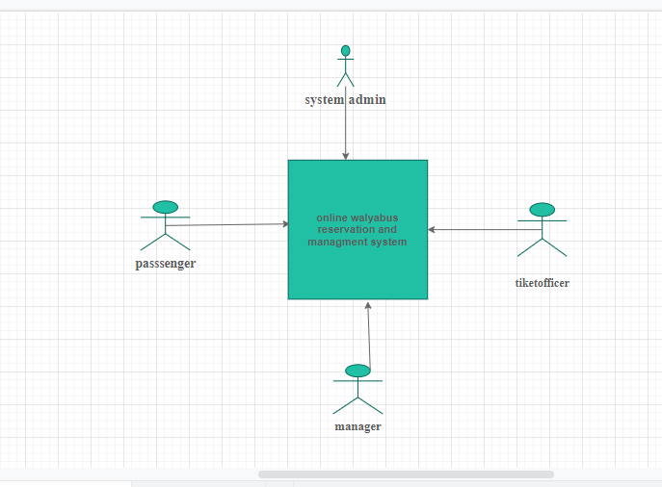

Figure 3. 1work flow of proposed system diagram

## 3.6. System use case Identification

The team identifies Actors and use cases associated with the system. The following table specifies the actors and use cases that a group member have identified with in the proposed system. The actors that interact with the system are the passenger; ticket clerk, manager and administrator are users of the system. They are described here in brief: -

**Name: -** Passenger

**Description: -** passenger is a person who reserves bus ticket for traveling in the bus.

**Name: -** Ticket officer

**Description: -** ticket clerk is a person who is responsible for view the passenger information and also print ticket for the passenger.

**Name: -** Manager

**Description: -** Manager is a person who is responsible for manage bus, route, and the overall activities of the company.

**Name: -** Administrator

**Description: -** Administrator is a person who is responsible for manage user account.

Table 3. 1 List of Actors and Use Cases Associated with the new system

|  |  |
| --- | --- |
| Actor | Use case |
| Manager | * Log in * View reservation * Generate report * Add routes * Delete route * Update route * Add bus * Update bus * delete bus * postpone reservation * delete reservation * View comment * Post notice * Print report * Search route * Search reservation |
| Ticket clerk(officer) | * Log in * Add schedule * Delete schedule * Update reservation * View reservation * Cancel reservation * Search route * Print report * View comment * Search reservation * Delete reservation * View reservation * View routes * Print ticket |
| Passenger | * Check ticket availability * Reserve ticket * Cancel ticket * View schedule * Give comment * View notice * See availability of seats * View route |
| Admin | * Log in * Create account * Update account   ➢ Delete account |

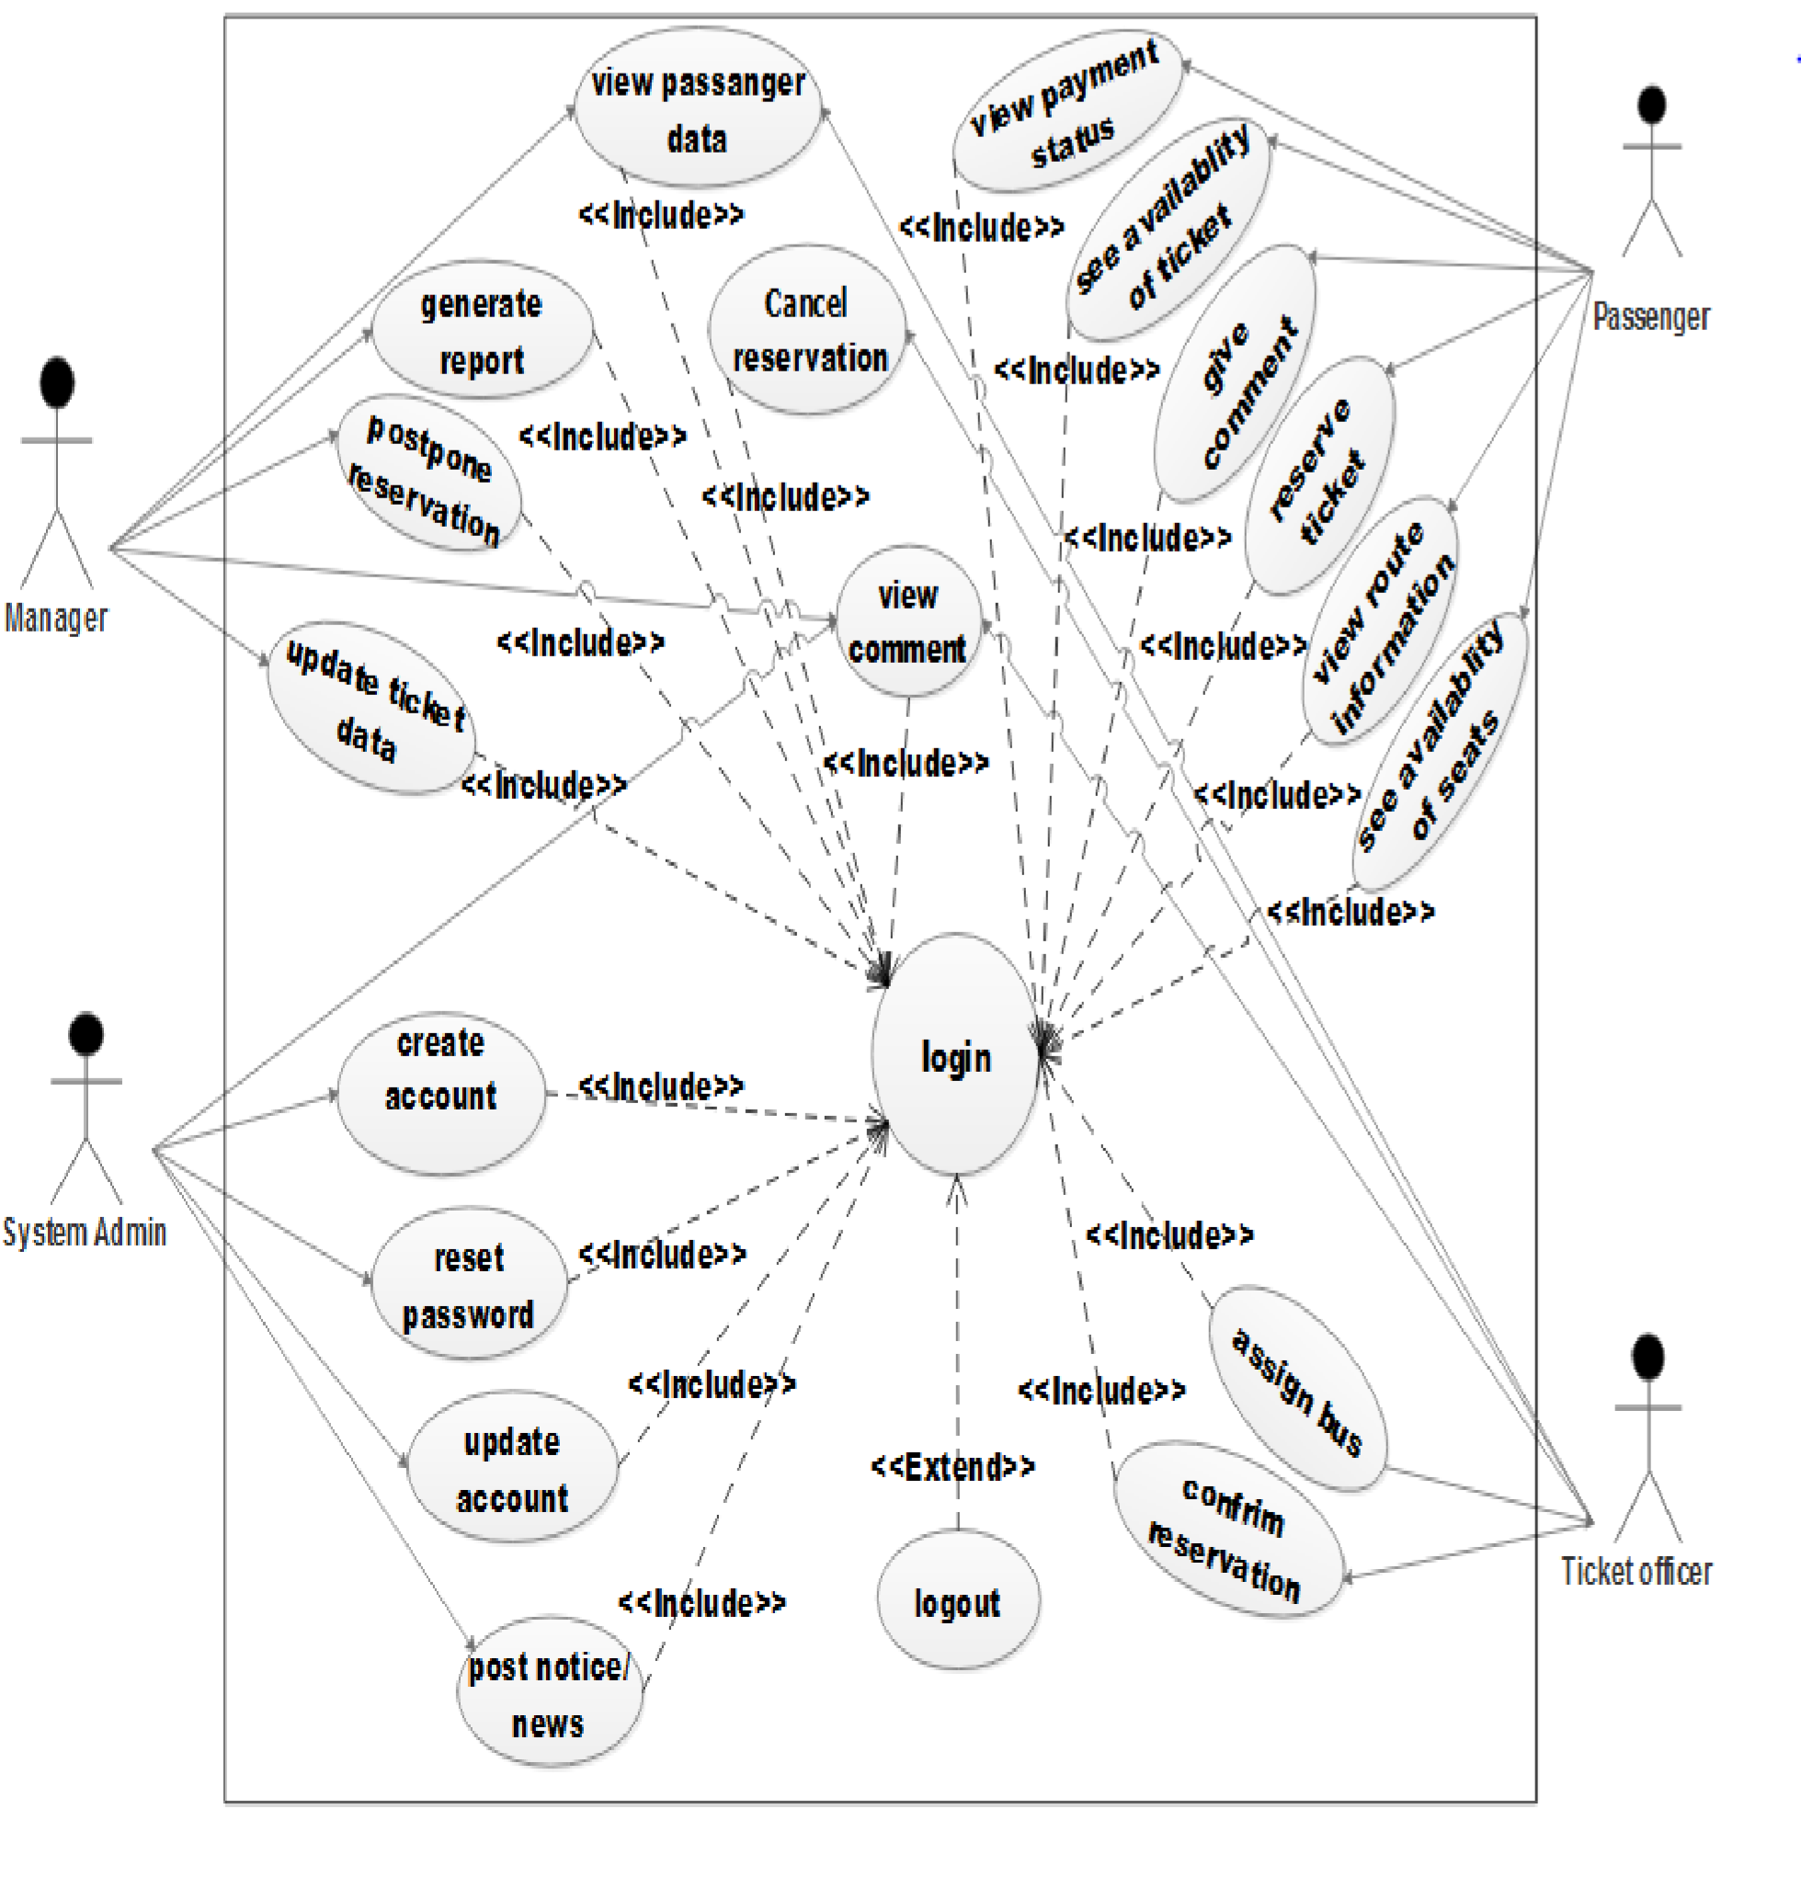

Figure 3. 2 use case diagram

## 3.7 Use Case Descriptions

The following consecutive tables show the use case narration for each of the use cases that has identified in the above use case diagram. Each table contains the use case name, the actor which initiates and interacts with the use case, description of the use case and typical course of events that show the interaction between the actor and the use case which enable the team to easily depict the functions of the proposed system. Some typical description of our systems described as follows:

table 3. 2 Use case description for login use case

|  |  |
| --- | --- |
| Use case name | Log in |
| Use case identifier | UC-01 |
| Actor | admin, manger, and clerk |
| Description | It allows the existing user to login |
| Pre-condition | Admin, manager or clerk must have valid user name and password. |
| Post-condition | admin, manager and clerk |
| Basic course of action | 1. Admin, Manager or clerk browse the system. 2. Admin, Manager or clerk browse home page. 3. The system displays the login dialog box. 4. Admin, Manager or clerk fills user name and password and submits it to the system. 5. The system checks the login information whether it is valid. 6. Admin, Manager or clerk gets user profile. 7. Use case ends. |
| Alternative course of action | AC1: If the Admin, Manager or clerk (tiket officer) enter incorrect username and password combination the system display error message and the log in form display again. |
| Special requirements | ➢ A user must have username and password |

Table 3. 3 Use case description for reserve ticket

|  |  |
| --- | --- |
| Use case name | Reserve ticket |
| Use case identifier | UC-02 |
| Actor | Passenger |
| Description | This use case allows the passenger to make reservation |
| Pre-condition | None |
| Post-condition | None |
| Basic course of action | 1. Passenger browses the system. 2. The system displays the homepage. 3. Passenger browses the reservation page. 4. The system displays the reservation form. 5. Passenger fills the required information in the form then submits the form. 6. The system gives back the reservation id and journey information. 7. Use case end |
| Alternative course action | AC1: If the passenger fills incorrect combination of departure and destination the system displayed error message.  AC2: If ticket is not available the system does not allow reservation.  AC3: If passengers account balance is insufficient the system does not allow reservation. |
| Special requirement | ➢ A ticket must available |

Table 3. 4 use case description for cancel ticket

|  |  |
| --- | --- |
| Use case name | Cancel ticket |
| Use case identifier | UC-04 |
| Actor | Passenger |
| Description | It allows the passenger to cancel the reserved ticket |
| Pre-condition | None |
| Post-condition | The reserved ticket will be cancelled. |
| Basic course of action | 1. Passenger browses the system. 2. The system displays the homepage. 3. Passenger browses the ticket cancelation form. |
|  | 1. The system displays the ticket cancelation form. 2. Passenger fills the required data and submits the form. 3. The system display confirmation of ticket cancelation. 4. Use case end. |
| Alternative course of action | AC1:  ➢ If the passenger fills wrong data the system display the error message and gives the cancelation form again. |
| Special requirements | ➢ A passenger must reserve ticket |

Table 3. 5 Use case description for view schedule

|  |  |
| --- | --- |
| Use case name | View schedule |
| Use case identifier | UC-06 |
| Actor | Passenger |
| Description | This use case allows the passenger to see information related with journeys. |
| Pre-condition | None |
| Post-condition | It will show fare and time of the journeys. |
| Basic course of action | 1. Passenger browses the system. 2. The system displays the homepage. 3. Passenger browses schedule page. 4. The system displays the required page. 5. Passenger fills the required data then press search. 6. The system displays the information related with the search. 7. Use case end. |
| Alternative course of action | AC1:  ➢ If the passenger fills incorrect data the system displays error message and the view information page. |

Table 3. 6 Use case description for view reservation

|  |  |
| --- | --- |
| Use case name | View reservation |
| Use case identifier | UC-07 |
| Actor | Manager and ticket officer |
| Description | This use case allows viewing reserved bus and  Passenger information |
| Pre-condition | Manager or clerk must log in to the system. |
| Post-condition | The system will provide reserved information |
| Basic course of action | 1. Manager or officer browses the system. 2. The system displays the homepage. 3. Manager or clerk log in to the system. 4. Manager or clerk browses the view reservation page. 5. The system displays the requested page. 6. Manager or clerk click on view button 7. The system will display the required information 8. End of use case. |
| Alternative course of action | None |

Table 3. 7 Use case description for add route

|  |  |
| --- | --- |
| Use case name | Add route |
| Use case identifier | UC-09 |
| Actor | Manager |
| Description | This use case allow addition of a new route |
| Pre-condition | Manager must log in to the system. |
| Post-condition | New route will be added to the database. |
| Basic course of action | 1. Manager browses the system. 2. The system displays the homepage. 3. Manager log in to the system. 4. Manager browses’ the add route page 5. The system displays the requested page. 6. Manager fills the required data then submits the form. 7. The system displays message successfully compilation of use case. 8. End of use case. |
| Alternative course of action | AC1:  ➢ If Manager fill incorrect data the system display error message and the add route form. |

Table 3. 8 use case description Create account for ticket officer

|  |  |
| --- | --- |
| Use case name | Create account |
| Use case id | Uc-10 |
| Description | Administrator create account for clerk, admin, and manager |
| Actor | Administrator |
| Precondition | Administrator login in to the system |
| Flow of action | System response |
| Basic course of action | Step1: click on create button  Step2: The system displays the form  Step3:fill the form Step4: click register button  Step5: check the Validity.  Step6: the data sent to database.  Step7: Use case ends. |
| Alternative course of action | (If the password is not match or account is already exist)  The system displays password not match or account is already existry again.   * The system redirects to go step 3 i.e.to renter the password * Use case ends |
| Post condition | Account created Successful message. |

Table 3. 9 Use case descriptions for add schedule

|  |  |
| --- | --- |
| Use case name | Add schedule |
| Use case identifier | UC-12 |
| Actor | Ticket clerk |
| Description | This use case allow to add schedule |
| Pre-condition | Clerk must log in to the system. |
| Post-condition | Fare and time of the journey will be added. |
| Basic course of action | 1. Ticket clerk browses the system. 2. The system displays the homepage. 3. Ticket Clerk browses the add schedule page. 4. The system displays the requested page. 5. Ticket Clerk adds the information that supposed to be added and submit it to the database. 6. The system displays message successfully compilation of use case. 7. End of use case. |
| Alternative course of action | AC1:  ➢ If ticket clerk fill incorrect data in to the add schedule form the system will display error message and the added information page. |

Table 3. 10 Use case description for add bus

|  |  |
| --- | --- |
| Use case name | Add bus |
| Use case identifier | UC-14 |
| Actor | Manager |
| Description | This use case allow addition of bus |
| Pre-condition | Manager must log in to the system. |
| Post-condition | Bus will be added to the database. |
| Basic course of action | 1. Manager browses the system 2. The system displays the homepage. 3. Manager log in to the system. 4. Manager browses’ the add bus page 5. The system displays the requested page. 6. Manager fills the required data then submit the form. 7. The system displays message successfully compilation of use case. 8. End of use case. |
| Alternative course of action | AC1:  ➢ If Manager fill incorrect data the system displays error message and the add bus form. |

## 3.8 User Interface prototype

User interface (UI) prototyping is an iterative analysis technique in which users are actively involved in making up of the UI for a system. Interface prototyping is a technique used in user interface design to create and test the design of an interface. The outcome of interface prototyping is a visual representation of an interface in the form of an interface prototype.

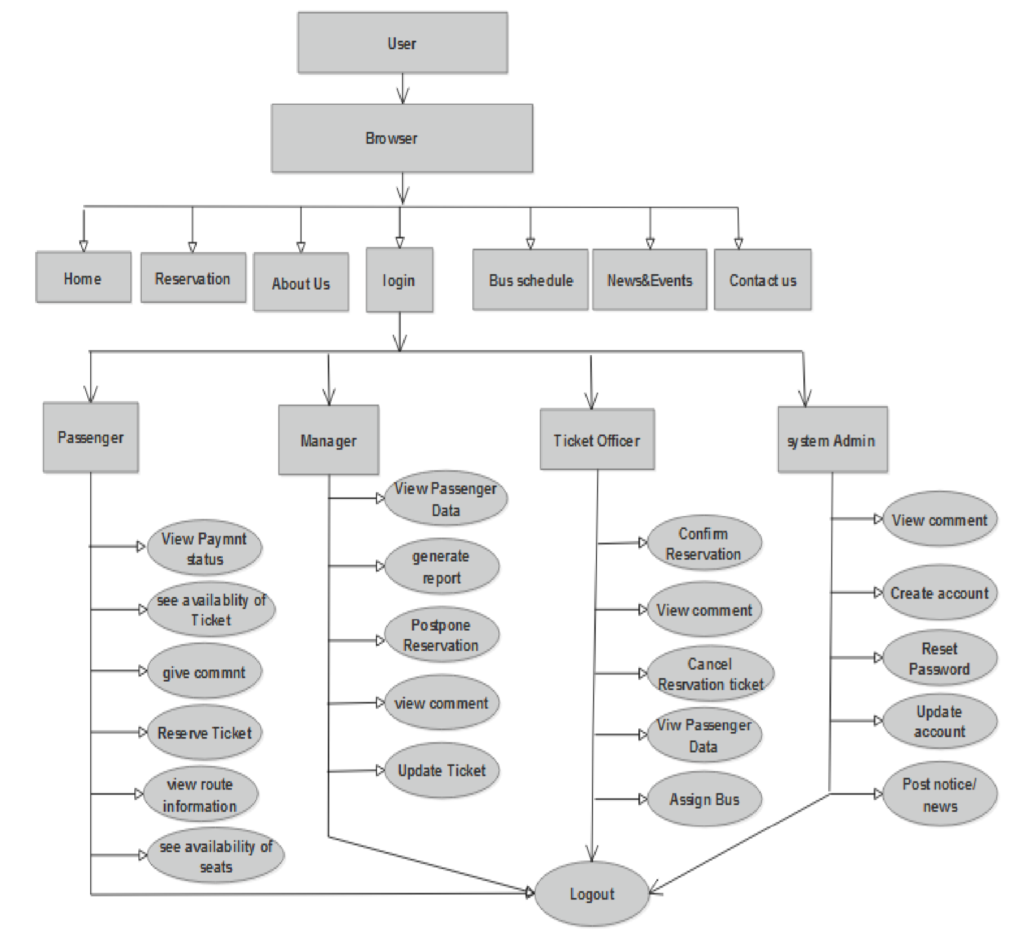

figure 3. 3 User Interface prototype

## 3.9. Activity diagram

An activity diagram is used to model a large activity's sequential work flow by focusing on action sequences and respective action initiating conditions. An activity diagram is represented by shapes that are connected by arrows. Arrows run from activity start to completion and represent the sequential order of performed activities. Circles represent an initial workflow state. Circle indicates an end state. Rounded rectangles represent performed actions, which are described by text inside each rectangle [7].

A diamond shape is used to represent a decision, which is a key activity diagram concept. Upon activity completion, a transition (or set of sequential activities) must represent parallel sub flows. The following are sample activity diagrams for Online walya bus Ticket Reservation system.

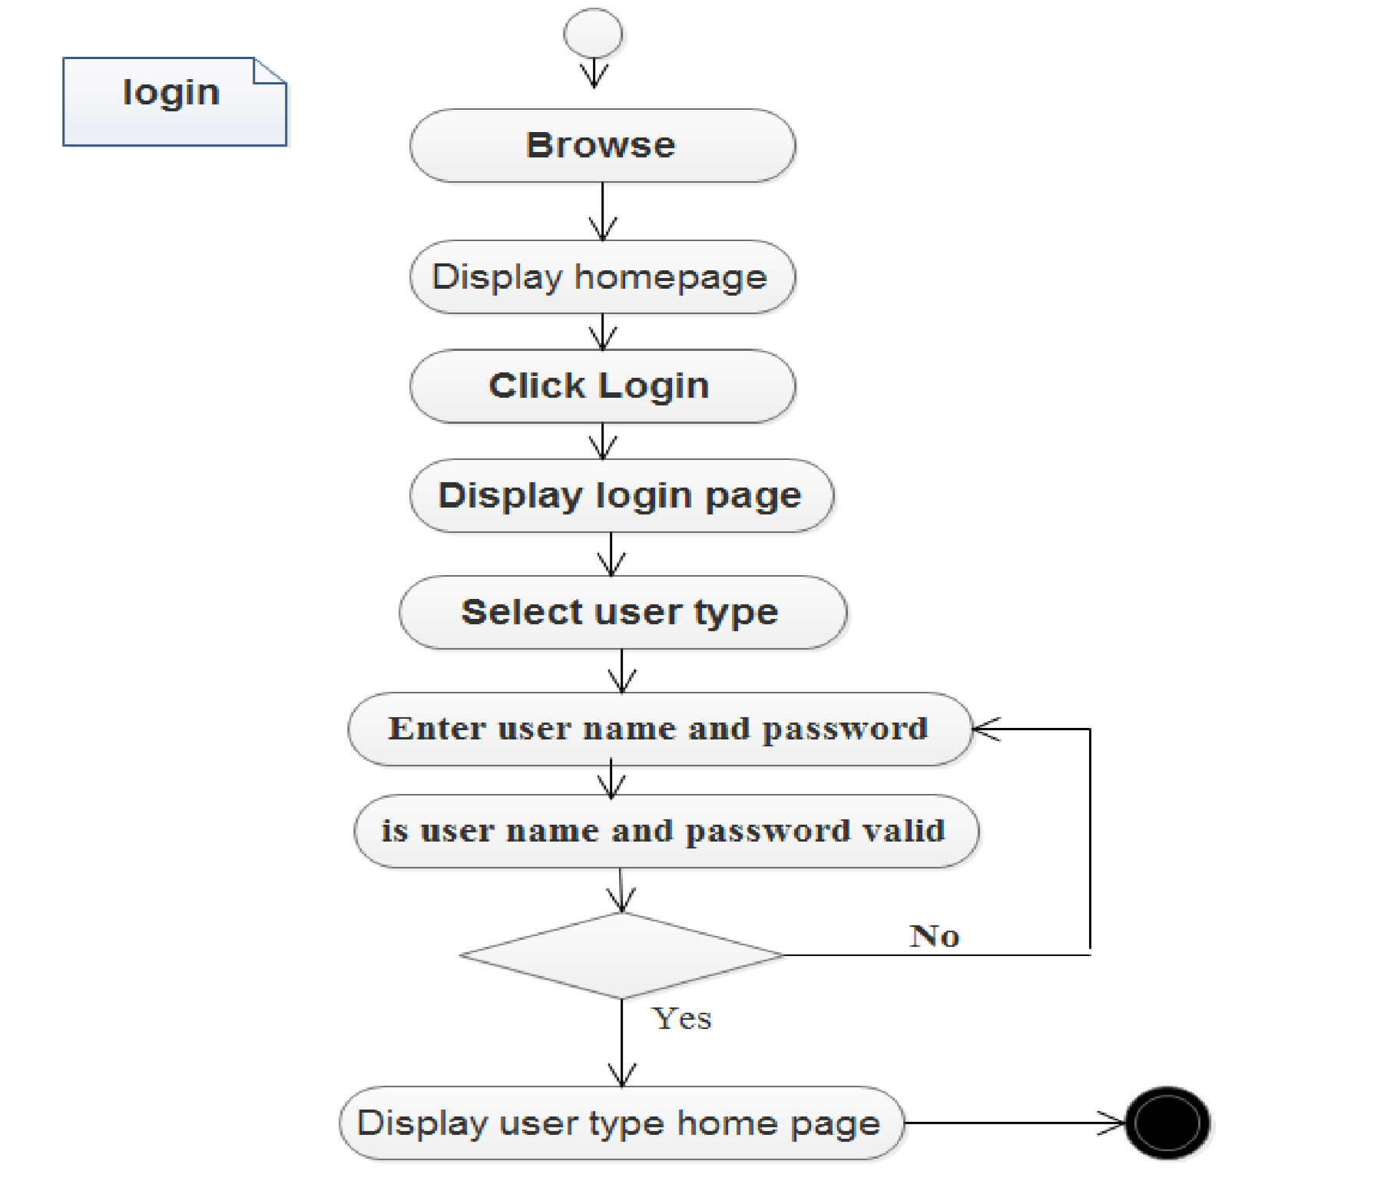

figure 3. 4 activity diagram for login

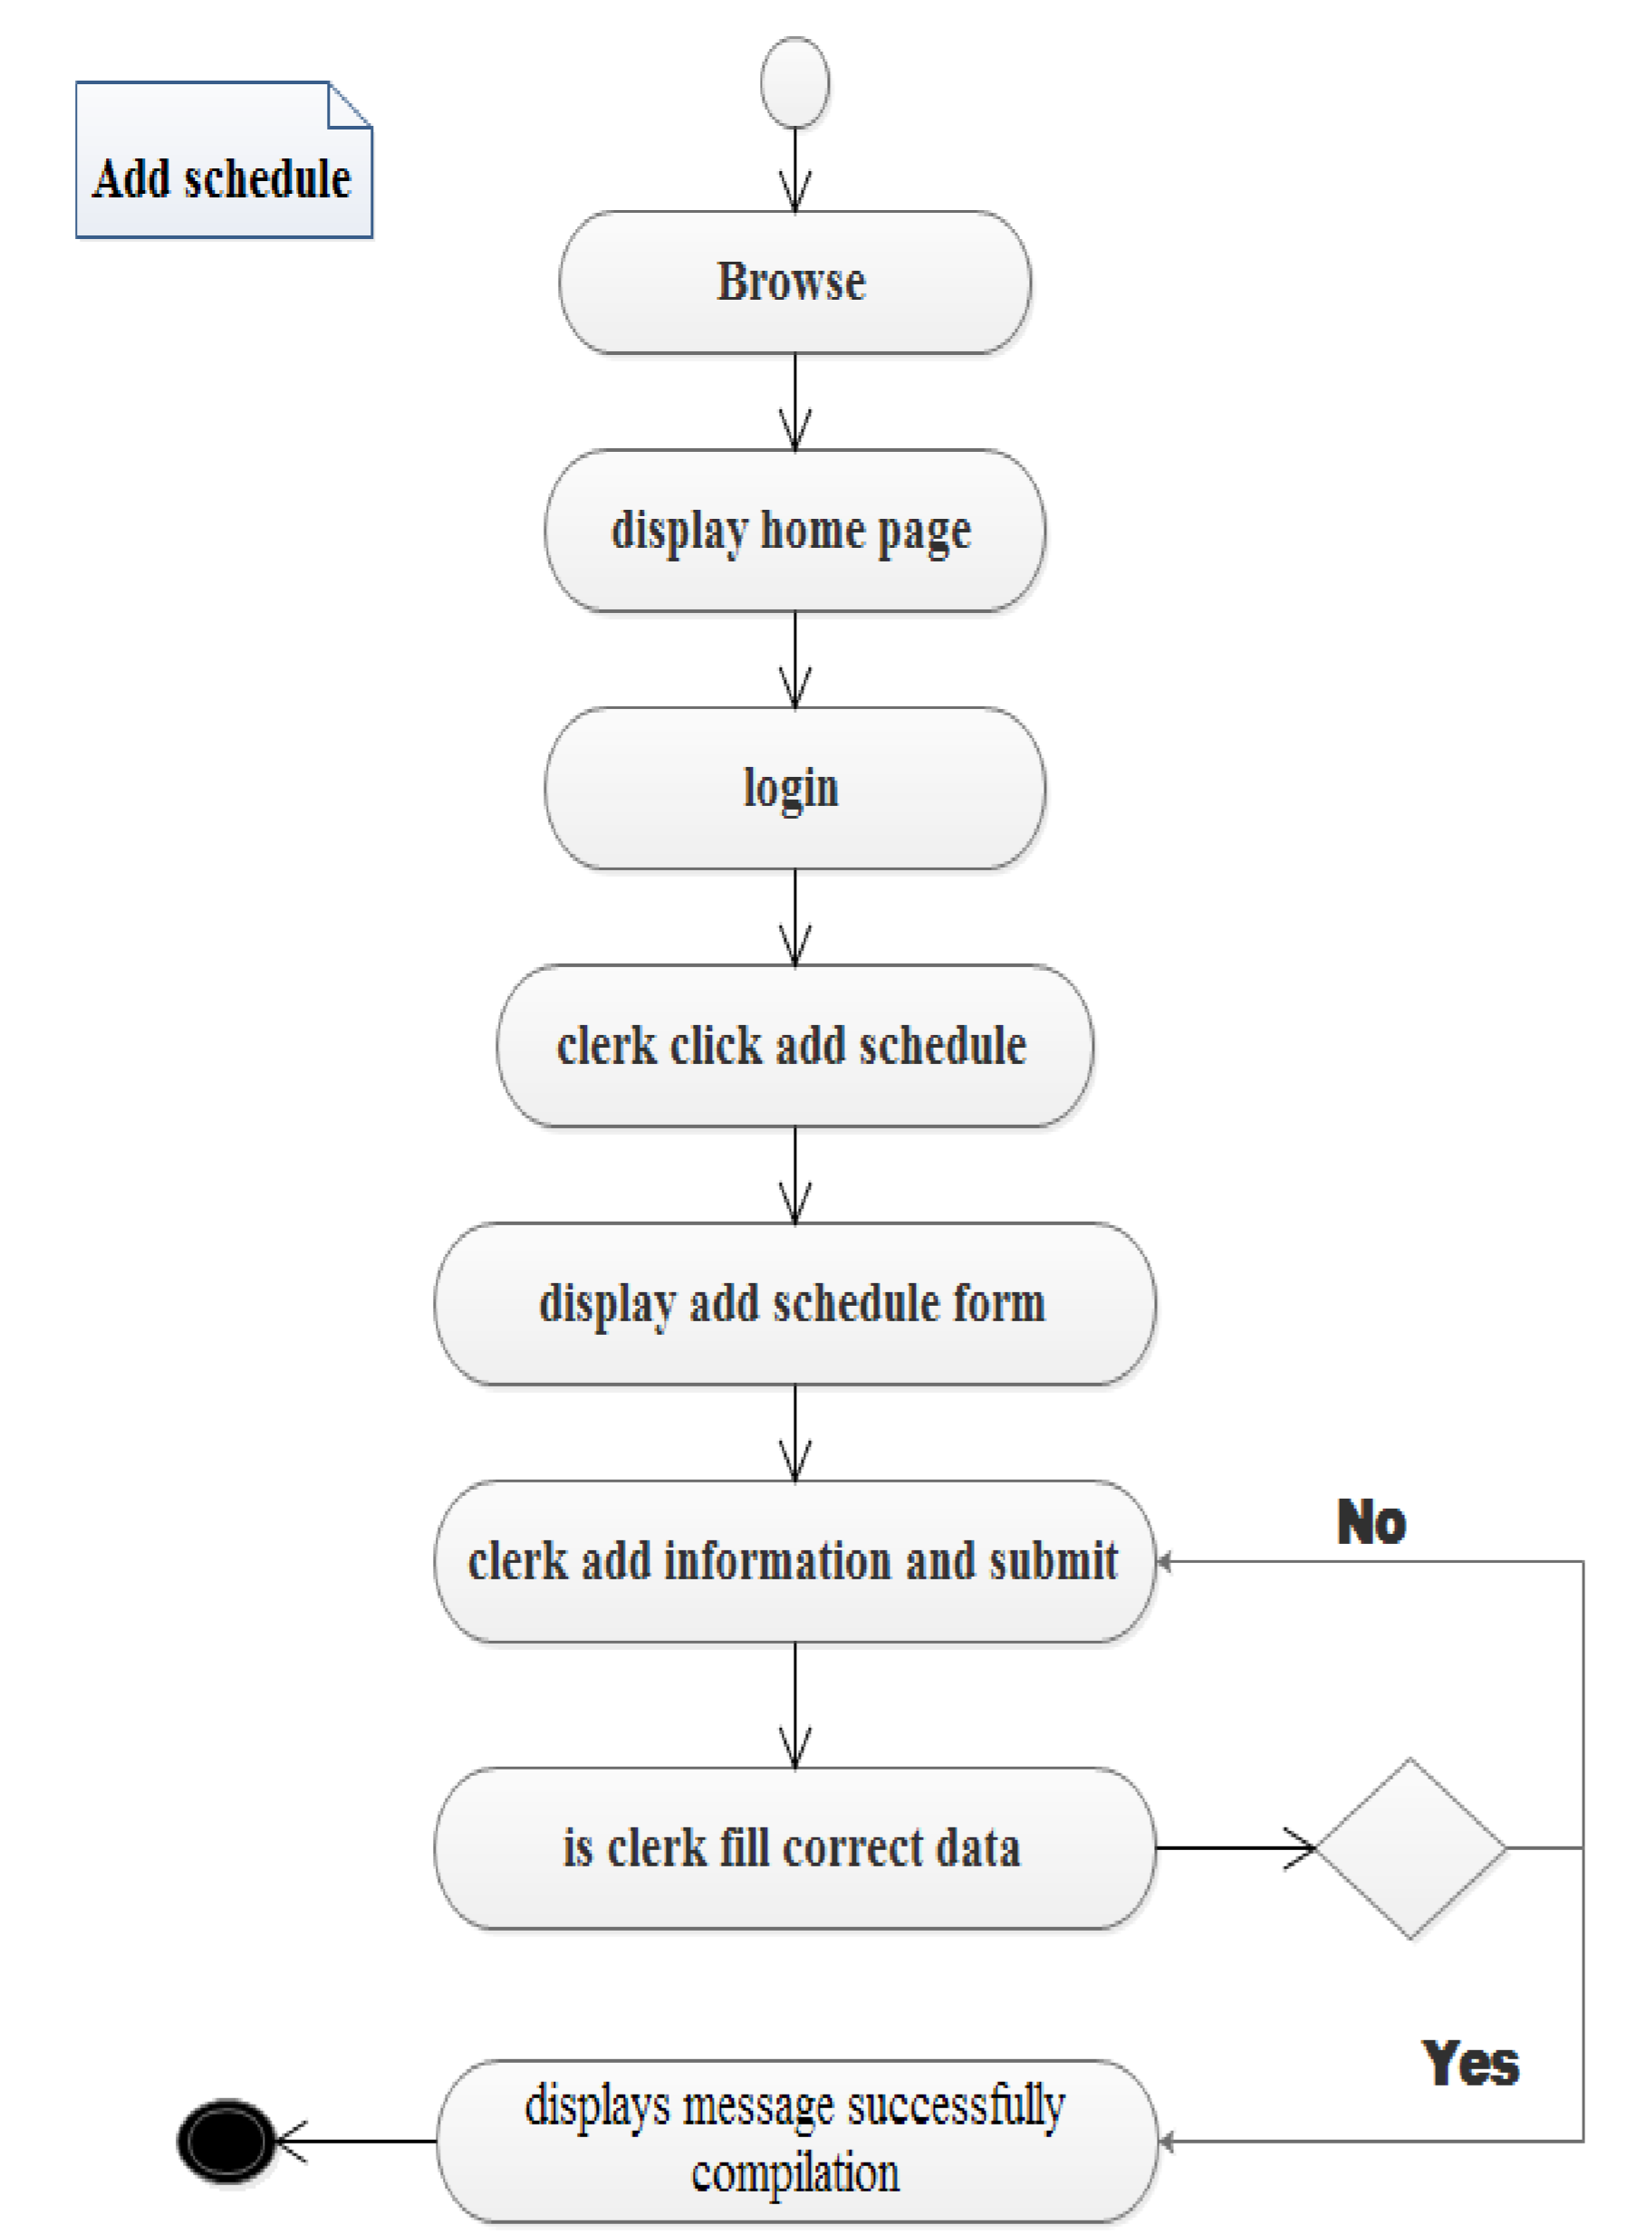

Figure 3. 5 add schedule activity diagram

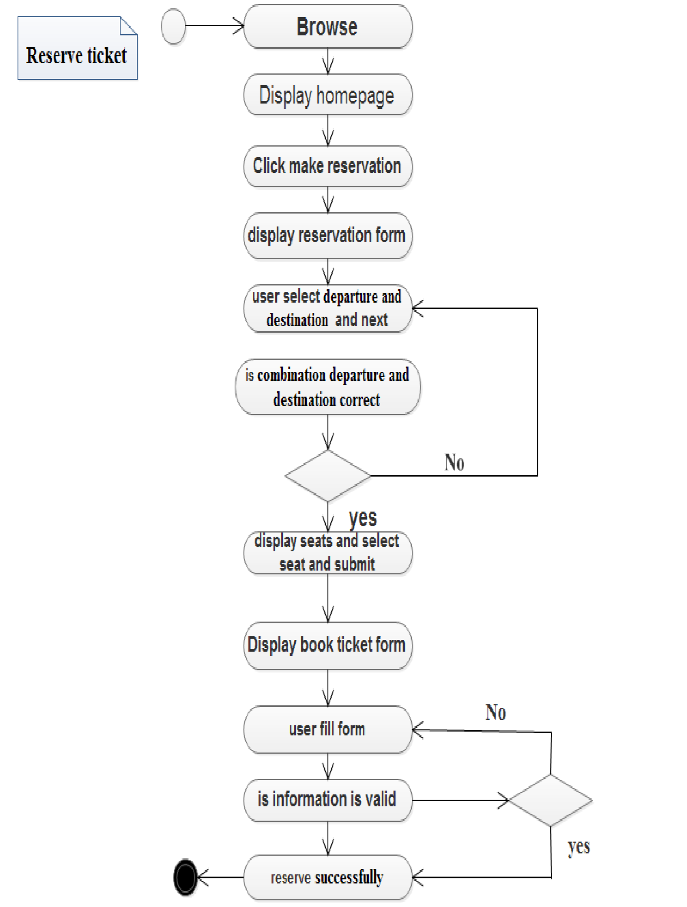

figure 3. 6 activity diagram for reserve ticket

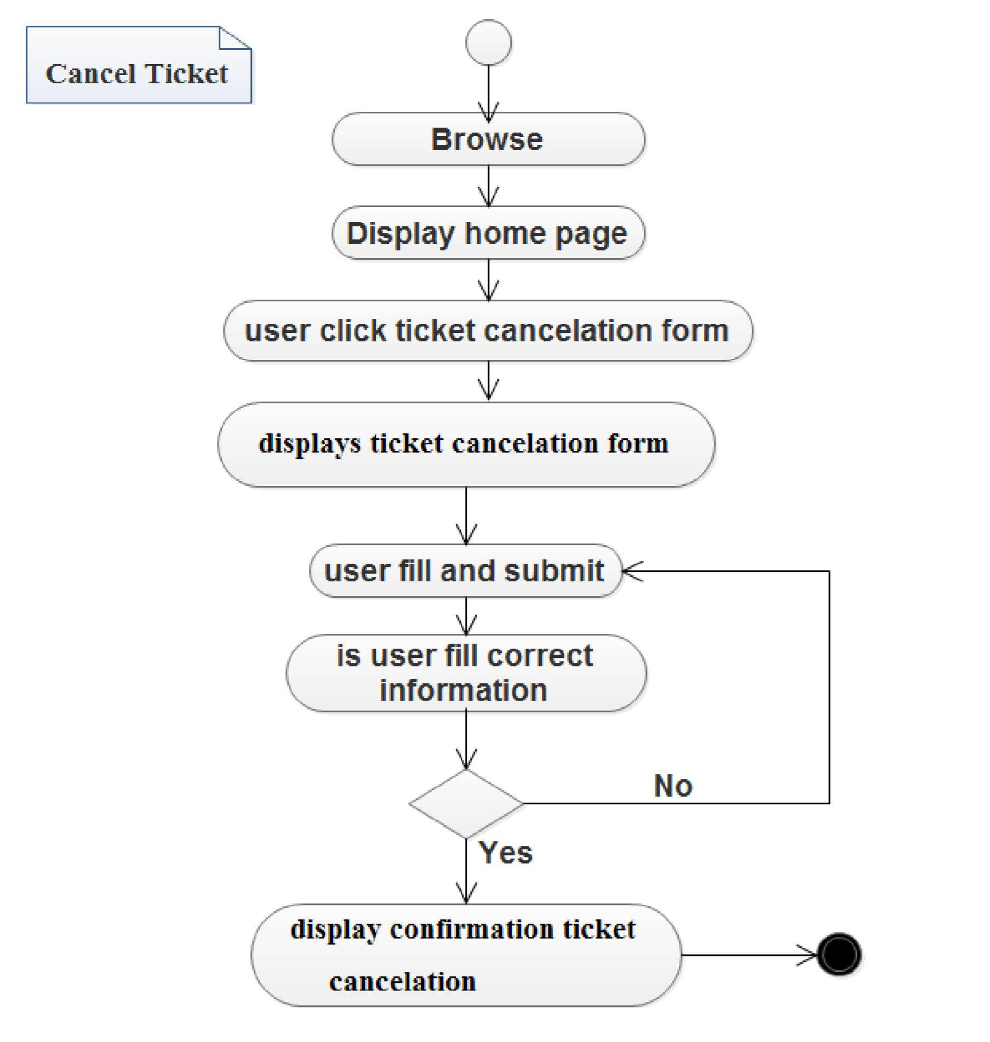

figure 3. 7 activity diagram for cancel ticket

## 3.10. Sequence diagram

A sequence diagram is an interaction diagram. From the name, it is clear that the diagram deals with some sequences, which are the sequence of messages flowing from one object to another. Sequence diagrams show the interaction between participating objects in a given use case. Sequence diagrams provide more detail and show the message exchanged among a set of objects over time[]. Sample of sequence diagram for walya bus ticketing system as follows:

#### 

Figure 3. 8 sequence diagram for create account

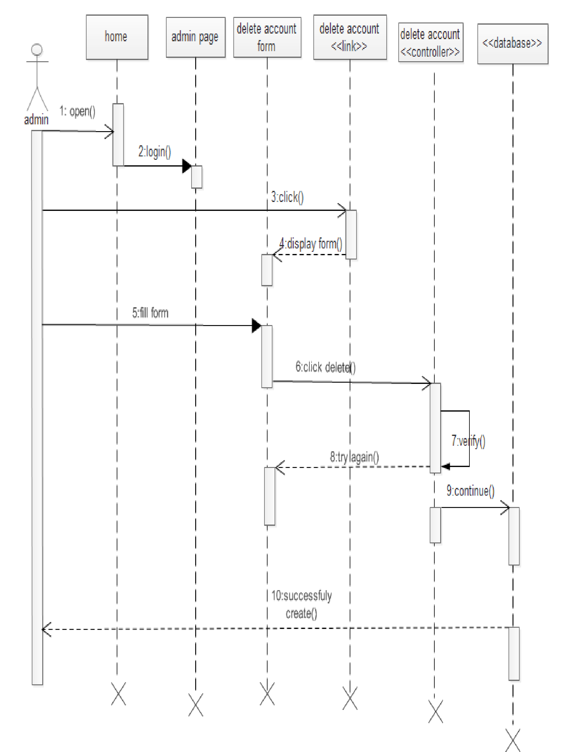

Figure 3. 9 sequence diagram for delete account

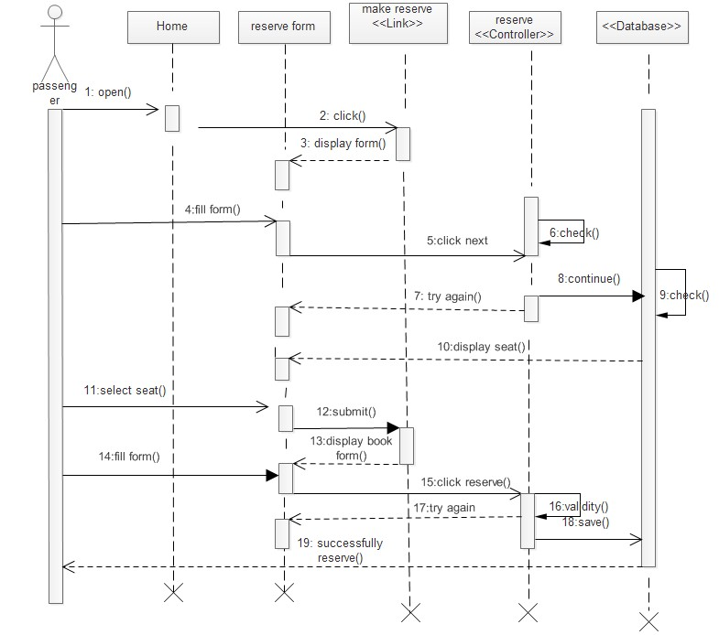

Figure 3. 10 sequence diagram for reserve ticket

## 3.11. System Design

**Design goals**

The design goals describe the qualities of the system that developers should improve. Design goals are, normally derived, from the non-functional requirements of the system. Hence, the followings sections describe the design goals of the system:

**Performance:** Response time of the System should be minimum. The system should show no visible deterioration in response time as the number of users or reservation data increases. The system does not take up too much space in memory to store system’s data.

**Usability:** The system should provide an easy-to-use graphical interface so user can easily learn how they use the system. The system should be user friendly so that users can use it easily without confusion. The web interface should be intuitive and easily navigable. Users should be able to understand the menu and options provided by the system.

**Availability:** The system will be accessible from any computer with internet and will be accessible anytime a user would want to use the system. Because the system is online, means to that it is accessible through at anytime, anywhere.

**Security:** Only manager has the right to change system parameters, such as update bus information, add and delete route. Users need to be registered before having access to any services of the system.

**Maintenance:** Our system is easily modifiable when there is need to upgrade the system functionality transactions more than from the current state. The source code for the system should be easily readable and understandable.

### 3.11.1 Deployment diagram

The deployment diagram models the hardware of the implementing environment. Deployment diagrams models the mapping of software pieces of a system to the hardware that is going to execute it. It also shows the relationship the hardware and software and how these components are work together in the machine. This diagram is given as follows

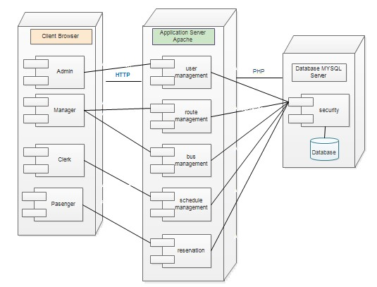

Figure 3. 12 deployment diagram

### 3.11.2 Architecture of the proposed system

The proposed system which is the software architecture used for the system is Repository architecture because subsystems access and modify data from a single data structure which is called the central repository. This architecture allows different user of the system access the data from center database server. The central repository of the proposed system is MySQL database server which is every data related with the system is stored.

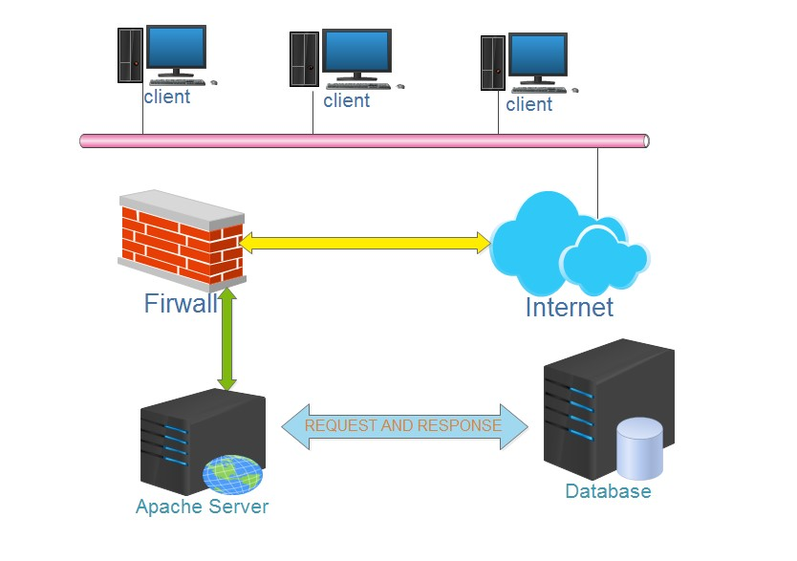

Figure 3. Architecture of the proposed system

### 3.11.3 Persistence modeling

Persistence modeling is the diagram that shows the relationship between the tables that interrelated with each other. It also shows self-relation of the tables. It is only used for object oriented database modeling; but for relational database modeling we use Entity Relationship modeling instead of Persistence to show the relation of tables with each other.

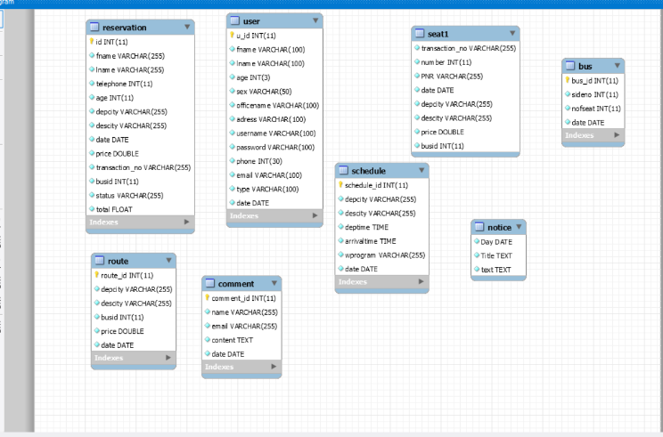

figure 3. 14 Persistence diagram

## 3.12. Class diagram analysis

A class diagram shows a set of classes, interfaces, and collaborations and their relationships. Class diagrams involve global system description, such as the system architecture, and detail aspects such as the attributes and operations within a class as well. So, our system provides as the following form of class diagram.[9]

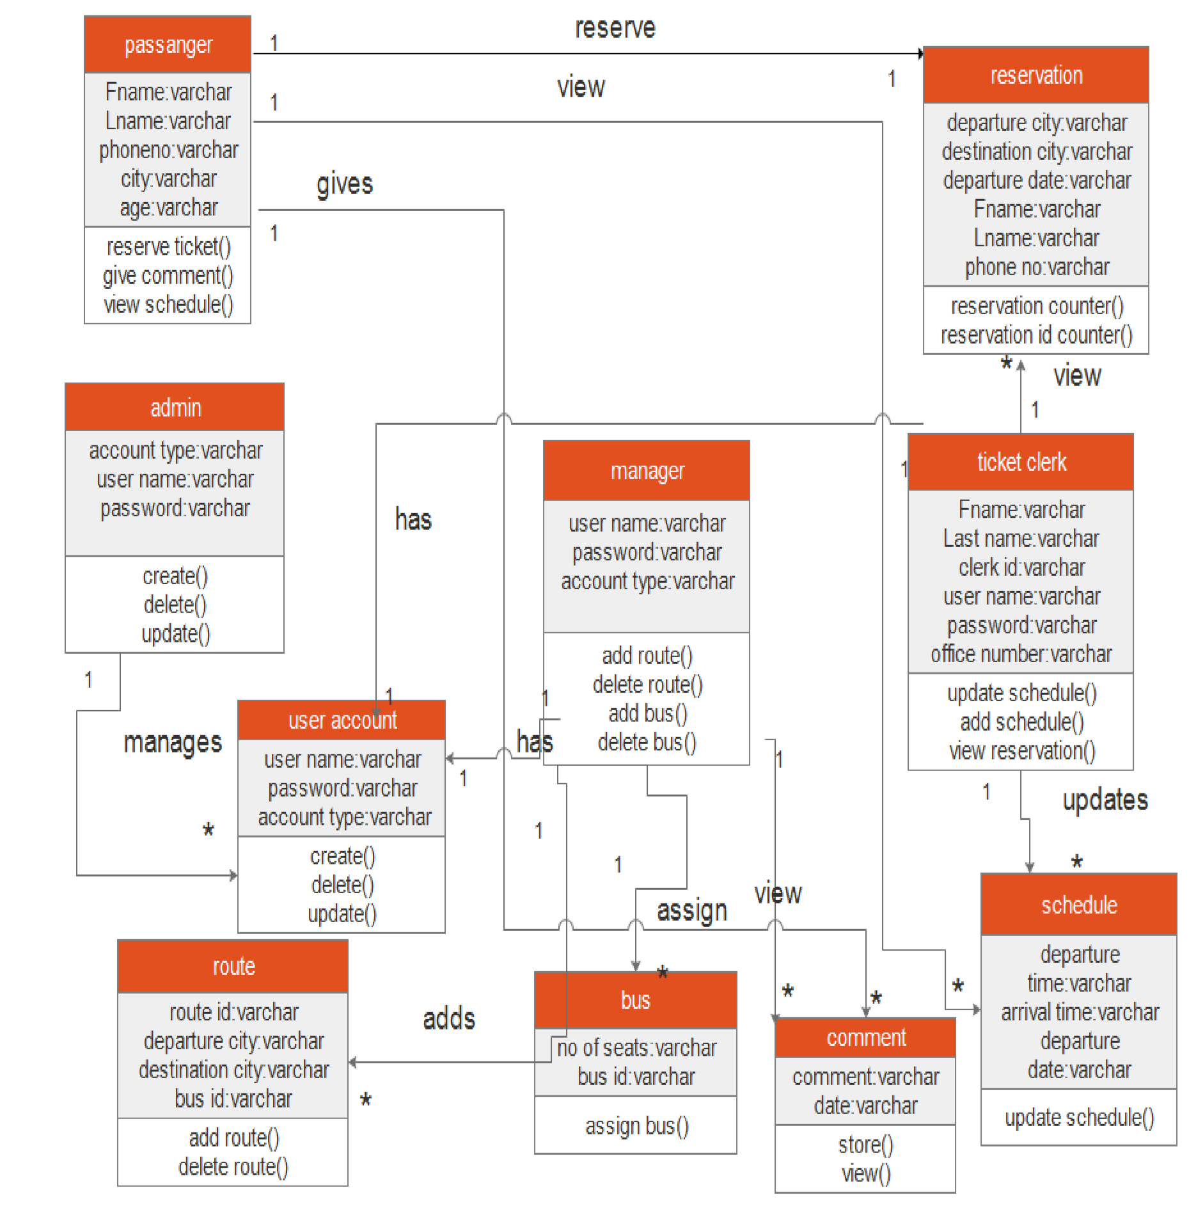

Figure 3.15 **class diagram**

# CHAPTER FOUR

# RESULT AND DISCUSSION

The result of this document helps to the users on how to work with the system. This document acts as a user manual and it helps to the users not to be confused with the system. It includes sample pages and sample code of our system. It gives the users a brief over view of the system. Our project result contains the code and its data base connection. The implementation is carried out with the results that have been obtained from the feasibility study and analysis. Then the system is tested with appropriate data inputs to check the successfulness of the system. This being carried out by inputting data that are of rare to be inputted. Then the system administrator will be trained of the operational functionalities to control and maintain system at a later stage. Implementation in the system includes implementing the attributes and methods of each object and integrating all the objects in the system, to function as a single system the implementation activity spans the gap between the detailed objects designed model and a complete set of source code file that can be compiled together.

**4.1 User Interface Design**

Here, the implemented system is described. How the user interacts with the system and some of the results of interaction with the system along with the screen shots are described. When the user starts to use a system homepage is displayed as shown below figure after this user can select item

and add the item to the cart when he needs to bought.

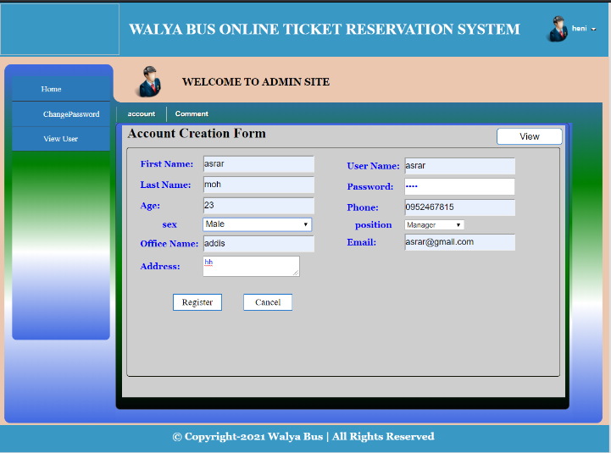

figure 4. 1 User interface for create login form

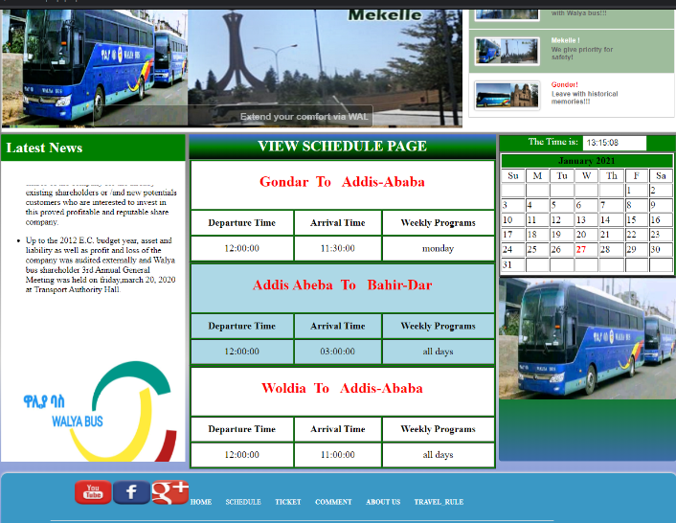

figure 4. 2 Figure User interface for view schedule

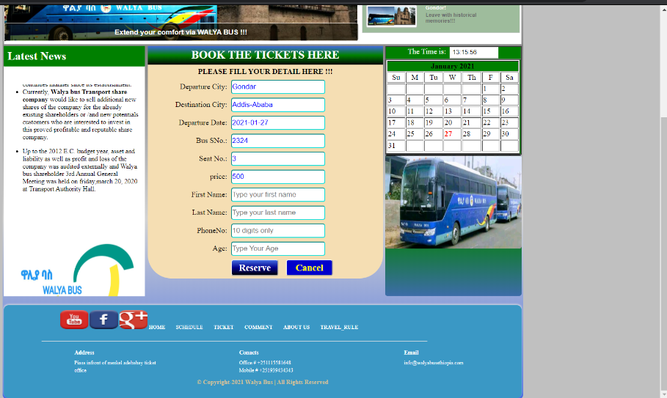

figure 4. 3 User interface for ticket reserving form

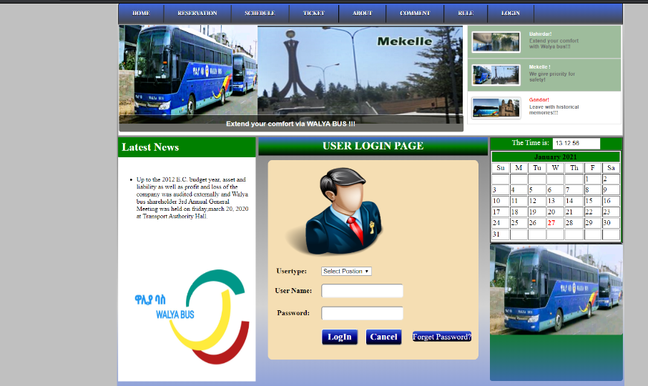

figure 4. 4 User interface login page

# CHAPTER FIVE

# CONCLUSION AND RECOMMENDATION

## 5.1 Conclusion

As we described in the chapter one proposal phase the current walya bus share company uses manual way ticket reservation system. Due to this the current system has different problem related with reservation. So the system we developed in the walya bus share company change in to the computerized way of ticket reservation. It is known that developing a system for an organization is not easy. But the team has tried its best and developed interesting web based walya bus online ticket reservation system. It is flexible, accurate and attractive with easy GUI approach. Generally, the team confidently can say that the software is partially successfully with negligible errors. Finally, the team expects the software will change this walya bus online ticket reservation system and makes it more reliable and efficient than the previous manual system.

## 5.2 Recommendations

The system we have developed is an application web based system it needs a skilled person to work with the system, so we recommend the system should be required the responsible and skilled person. We highly recommend the system should be kept in highly safe and favorable condition. Since this developed system is advanced our system have to recommend by walya bus traveler to accept and use this system because it is easy to use and save the time and resources’ for the walya bus online ticket reservation system Feature Improvement. The system that we develop now is very limited in scope and there are some needs to add to make it very interactive and well functional system. Why we did not finish now all functionality is that do to the shortage of time and other constraints. So for the future we try to do by including the following.

* Online payment. This is not implemented in this stage of our project development Because, it needs linking with the banking system, so researchers who are willing to conduct project in this area needs to be think about online payment by forming contact with bank system.
* Email subscription.
* Tacking system

## 6.3 Constraints

The following requirements are general constraints when doing this project are: -

* The spread of corona virus (covid 19).
* There is Shortage of time to complete project within the given time.
* Resources like internet connections are not consistently available.
* There is over load of examination and other projects.

# REFERENCES

|  |  |
| --- | --- |
| [1] | "www.tutorialspoint.com/uml/uml_activity_diagram.htm," [Online]. |
| [2] | "www.reserchgate .net/publucation/online bus Tiketing reservation system," european, [Online]. Available: https:researchgate.com. |
| [3] | "www.tutorialspoint.com/uml/uml_activity_diagram.htm," [Online]. |
| [4] | "www.google.com," 2019. [Online]. Available: www.google.com. |
| [5] | *walya bus transportation branch ofiice clerks.* [Interview]. |
| [6] | AAU, "vehicle tracking and security system.DOX". |
| [7] | Melisa ,K.(2007), "online bus tiketing system," 17 december 2003. |
| [8] | "Mobile based application tiket reservation systemsystem," no. 12, p. 32, 2019. |
| [9] | "https://www.lucidchart.com/pages/uml-activity-diagram?a=0," [Online]. |
| [10] | "European Centror Research Training and Development UK (www.eajournals.org)," 2003. [Online]. Available: http://www.traindev.get. |
| [11] | "1. https://www.tutorialspoint.com/software_architecture_design/data_centered_architect ure.html.," [Online]. |

# APPENDEXIES

1. **Tables for use case description**

|  |  |
| --- | --- |
| Use case name | Check ticket |
| Use case identifier | UC-05 |
| Actor | Passenger |
| Description | This use case allow the passenger to check if the ticket is available |
| Pre-condition | None |
| Post-condition | Shows the availability of ticket |
| Basic course of action | 1. Passenger browses the system. 2. The system displays the homepage. 3. Passenger access system via UC1. 4. Passenger browses the check ticket availability page. 5. The system displays the required page. 6. Passenger fills the required data then submits the form. 7. The system gives the status of the ticket. 8. Use case end. |
| Alternative course of action | AC1: If passenger fills incorrect data the system displays error message and the check availability page. |
|  | AC2: If incomplete form is submitted the system display error message and the check availability page. |

Use case descriptions for generate report

|  |  |
| --- | --- |
| Use case name | Generate report |
| Use case identifier | UC-08 |
| Actor | Manager and ticket officer |
| Description | This use case allow to generate report about every journey |
| Pre-condition | Manager and clerk must log in to the system. |
| Post-condition | It will generate report |
| Basic course of action | 1. Manager and clerk browse the system. 2. The system displays the homepage. 3. Manager and clerk log in to the system. 4. Manager and clerk browse the generate report page. 5. The system displays the requested page. 6. Manager and clerk click on generate report button 7. The system generates the report 8. End of use case. |
| Alternative course of action | None |

1. **programming codes**

*<?php*

*require("conection/connect.php");*

*$tag="";*

*if (isset($_GET['tag']))*

*$tag=$_GET['tag'];*

*?>*

*<!DOCTYPE HTML PUBLIC "-//W3C//DTD HTML 4.0 Transitional//EN">*

*<html>*

*<head>*

*<title> Walya bus transport system</title>*

*<meta name="robots" content="index, follow">*

<meta name="keywords" content="walyabus">

<meta name="description" content="walyabus">

<meta http-equiv="Content-Type" content="text/html; charset=iso-8859-1" />

<link rel="stylesheet" href="css/header.css" type="text/css" />

<link href="themes/2/js-image-slider.css" rel="stylesheet" type="text/css" />

<link type="text/css" href="css/new.css" rel="stylesheet" />

<script src="js/new.js" type="text/javascript"></script>

<script src="themes/2/js-image-slider.js" type="text/javascript"></script>

<link type="text/css" href="css/menu1.css" rel="stylesheet" />

<link type="text/css" href="css/dropdown_menu.css" rel="stylesheet" />

<link rel="stylesheet" type="text/css" href="css/datepicker.css" />

</head>

<body style="background-color:silver">

<table id="t" align="center" >

<tr>

<td colspan="3">

<?php

include("include/header.php");

?>

</td>

</tr>

<tr valign="top">

<td >

<?php

include("include/left.php");

?>

</td>

<td width="500px">

<div id="center">

<div id="welcome">

<h2 align="center" style="padding-top:5px;">BOOK THE TICKETS HERE</h2>

</div>

1. **Diagram Collections**



Fig Activity diagram for cancel ticket

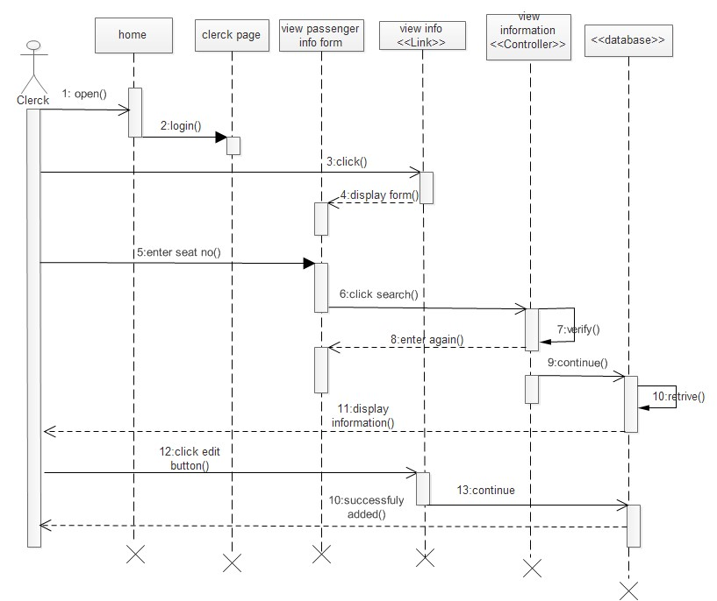

Fig sequence diagram or print ticket